Invoice
17.11.2006

Name: Emma Vieceli

Address: 85 Covent Garden, Cambridge, England, CB24 5GD

Job description: Grapevine Entertainment – London Manga Project

Deadline: Ongoing / to be set

Specifics: Character design sheets x 5

Rate of pay: £20/$40 per hour

Hours spent: (rounded down) 3 hours per sheet = 15 hours

Total amount payable now: £300/$600

Please make cheque payable to: Emma J Vieceli

Or, ideally, transfer payment to the following details:


Miss E J Vieceli
Barclays Bank – De Burgh House, Market Rd., Wickford, Essex.

a/c No.: 00260940

Sort Code: 20-04-96

With thanks in advance,
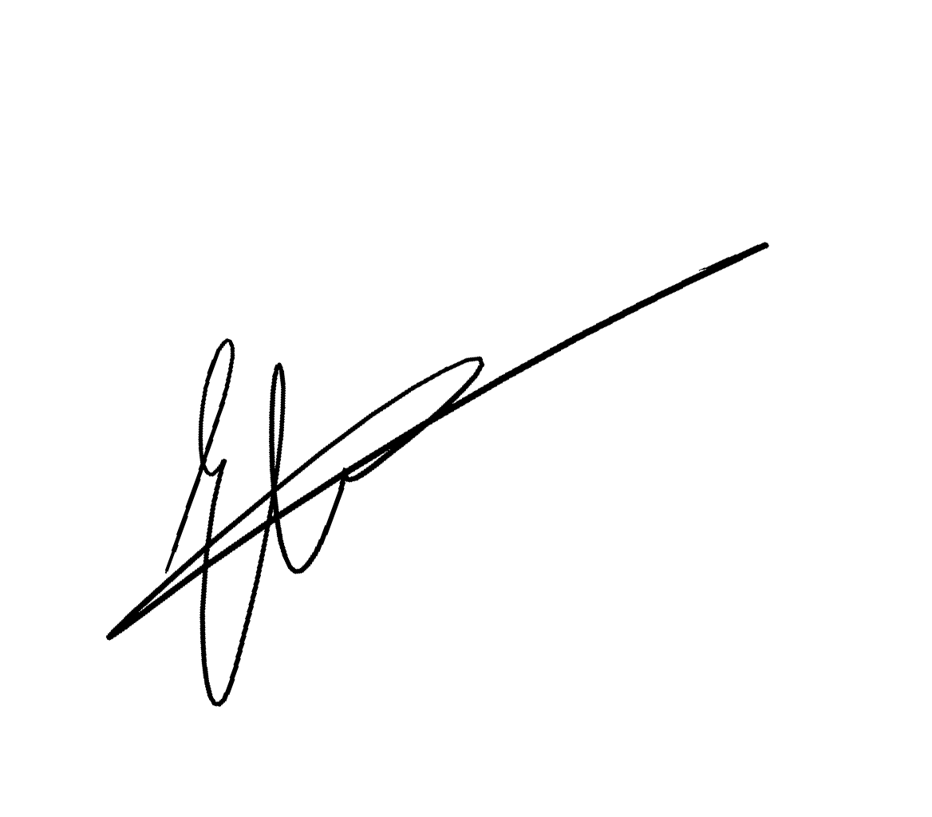
Emma Vieceli

www.sweatdrop.com
http://emma.sweatdrop.com

